Branca, Glenn (b. Harrisburg, Pennsylvania, 1948)

Patrick Nickleson

Glenn Branca is an American composer noted for his works for massed electric guitars. Branca began his compositional career in New York after working in theatre in Boston. With his first two bands The Static and Theoretical Girls he began combining avant-garde art music with the No Wave scene of late 1970s New York. Following these early experiments, Branca started his own ensemble – which over the years included members of the rock bands Sonic Youth, Swans, and Helmet – for his albums Lesson No. 1 and The Ascension. His works are heavily influenced by the esoteric tuning theories of Hermann von Helmholtz, Dane Rudhyar, Hans Kayser, and Harry Partch. From these writers and his own early experiments, Branca developed a compositional style that utilized the clashing of high harmonics at extreme volumes to create an effect that is often described as ecstatic. While his use of the term “symphony” to describe his large-scale works drew criticism earlier in his career, he has become an extremely prolific writer in that genre; his Symphony No. 15: Running Through the World Like an Open Razor (for strange orchestra) premiered at New York’s Le Poisson Rouge in November 2010.

Solo video (1978): http://www.youtube.com/watch?v=sqHz7cUw4Ls
- originally from Lesson No. 1 CD on Acute Records.

Branca photo:
http://www.primaverasound.com/galeria/bcn/plog-content/images/2011/concertsconciertosshows/glenn-branca-ensamble-01-susana-lopez-blanco.jpg

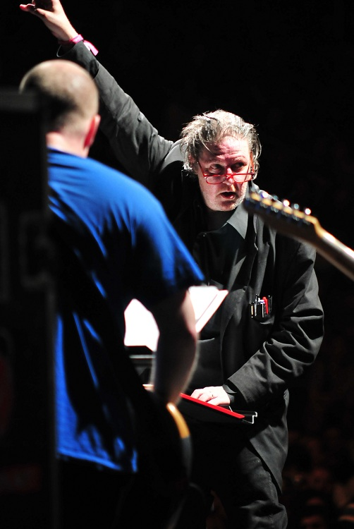

Further Reading:

Duckworth, William. “Glenn Branca” in Talking Music: Conversations with John Cage,
Philip Glass, Laurie Anderson, and Five Generations of American Experimental
Composers. New York: Schirmer, 1995. (Conversation between Branca and composer William Duckworth.)

Gagne, Cole. “Glenn Branca” in Soundpieces 2: Interviews with American Composers.
Meuchen, NJ: Scarecrow Press, 1993. (Conversation between Branca and Gagne.)

Gagne, Cole. “Glenn Branca” in Grove Music Online. (Encyclopedia entry; focuses
on expanding instrumentation across Branca’s works.)

Gann, Kyle. “Glenn Branca” in American Music in the Twentieth Century. New York:
Schirmer, 1997: 301-304. (Longest published overview of Branca’s career and music; includes analysis of tempo canon in second movement of Symphony No. 10.)

Ranaldo, Lee. “The Ascension – Liner Notes”, liner notes to The Ascension. ACT002,
2003. (Essay by Sonic Youth guitarist about the recording of Branca’s most famous album, including discussion of New York as it was during the early 1980s when the ensemble was first forming.)

Partial Discography:

Lesson No. 1 (99 Records, 1980/2004)
The Ascension (99 Records, 1981; Acute Records 2003; Fortissimo Records, 2010)
Indeterminate Activity of Resultant Masses (Atavistic 1981; Atavistic 2007)
Symphony No. 3 (Gloria) (Atavistic, 1983)
Symphony No. 2 (The Peak of the Sacred) (Atavistic, 1992)
The World Upside Down (Crepuscule, 1992)
Symphony No. 6 (Devil Choirs at the Gates of Heaven) (Atavistic 1993)
The Mysteries (Symphonies Ns. 8 & 10) (Atavistic, 1994)
Symphony No. 9 (l’eve Future) (Point, 1995)
Symphony No. 5 (Describing Planes of an Expanding Hypersphere) (Atavistic, 1996)
Songs 77-79 (Atavistic, 1996)
Symphony No. 1 (Tonal Plexus) (ROIR, 1998)
“Movement Within” on Bang On a Can’ Renegade Heaven (Cantaloupe, 2000)
The Ascension: The Sequel (Systems Neutralizers, 2010)
Symphony No. 7 (Graz) (Systems Neutralizers, 2011)

